**Open-Ended Lab Assignment**

**Create a brand new project called OpenLab.**

Methods with a common purpose are placed in a class. The picture below was shown in your chapter and created with three the **Background**, **House** and **Tree** classes. Each class has multiple methods, one of those must be a constructor.

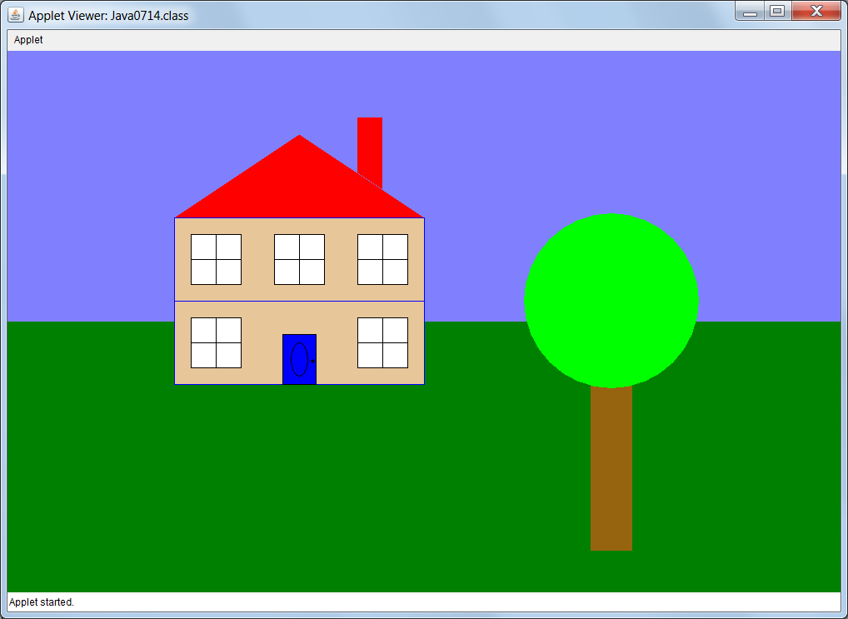

This is your first *open-ended* lab assignment. This means that you are not shown a specific picture or program computation output that is required when you execute your lab assignment. You need to create a graphics display. This display requires one or more classes and each class requires multiple methods.

Your program has a total of three classes:

* first class with four or more methods
* second class with three or more methods
* third class with two or more methods

**Remember…**

The program will not receive credit if you place program statements, except for method calls, inside the **paint** method.

All the methods you create must be placed inside a class.

Make sure to use self-documenting identifiers. (Variable names that describe what you are storing)